**Title: Examining Methods for Solving the Traveling Salesman Issue: Implementation, Assessment, and Analysis**

**Overview:**

The Traveling Salesman Problem (TSP) is an essential issue in graph theory and optimization, and it is one of the major challenges in computer science. TSP basically involves finding the shortest path that travels to each city once and then returns to the starting point. Though seemingly straightforward, TSP has significant computational complexity, which makes it an interesting topic with a wide range of practical applications.

TSP is applicable to a number of fields, including as network architecture, logistics, and transportation. An efficient TSP solution, for instance, can optimize delivery routes in logistics, cutting down on resource use and trip time. Similarly, TSP helps determine the hole drilling order that minimizes costs in circuit board fabrication.

This work endeavors to investigate TSP through the application, assessment, and examination of several algorithms specifically designed to tackle this issue. Through the analysis of various algorithmic strategies, our goal is to reveal the advantages and disadvantages of each method and shed light on their real-world applications.

**Context:**

Formally speaking, the Traveling Salesman Problem (TSP) is described as follows: given a set of cities and their respective distances from the initial city, identify the shortest route that visits each city precisely once and returns to the original city. TSP can be mathematically represented as a full graph, where distances are the edges and cities are the vertices.

A significant feature of TSP is its computational difficulty; it falls within the category of NP-hard problems, meaning that there isn't a polynomial-time algorithm for an optimal solution in every situation.

As a result, scientists have created a variety of algorithmic techniques to effectively approximate TSP solutions.

For TSP, heuristic, metaheuristic, and brute force approaches are common algorithmic paradigms. In large instances, brute force becomes impractical because it takes examining every possible combination of cities to determine the best path. Heuristic algorithms, such as the nearest neighbor strategy, choose the closest unexplored city at each phase to provide quick but poor results. Advanced strategies for exploring the solution space and avoiding local optima are provided by metaheuristic approaches like simulated annealing and genetic algorithms.

**Algorithms Put Into Practice:**

This section describes the algorithms used to solve the Traveling Salesman Problem (TSP) and offers an understanding of how they work.

Brute Force method: To find the quickest route, the brute force method thoroughly looks through every possible combination of cities. Although it is straightforward and ensures the best possible outcome, its time complexity increases exponentially with the number of cities, making it impractical for large-scale issues.

The nearest neighbor algorithm iteratively chooses the closest unexplored city from a starting point that is chosen at random. Due to its short-term decision-making, it may not always produce an optimal route even when it provides a quick heuristic solution.

Genetic Algorithm: Using an iterative process, genetic algorithms refine a population of potential solutions by simulating natural selection and evolution. Genetic algorithms search the solution space and converge on viable solutions by combining selection, crossover, and mutation; tweaking parameters is a critical component of performance optimization.

The technique known as "simulated annealing" involves progressively cooling a material to reduce energy consumption. It is modeled after metallurgical annealing. Similarly, temperature scheduling balances exploration and exploitation in simulated annealing, which probabilistically accepts poor solutions to escape local optima and thoroughly explore the solution space.

**Methodology for Benchmarking:**

In order to assess how well an algorithm performs when solving the Traveling Salesman Problem (TSP), benchmarking is essential. This section describes our experimental strategy for evaluating the implemented algorithms' efficacy and benchmarking them.

Experimental Configuration: A quad-core desktop machine with enough RAM and a standard configuration was used for the experiments. Python and C++ were among the programming languages utilized for benchmarking and algorithm implementation.

Benchmark Instances: A wide range of benchmark instances with different sizes and levels of complexity were used to assess the scalability and resilience of the method. These examples tested the computational limits of algorithms and ranged in size from small-scale to large-scale issues.

Performance Metrics: Runtime and solution quality were used to assess algorithm performance. Route length is a measure of solution quality, with lower values denoting more ideal solutions. Runtime measures the amount of time needed to find a solution and represents computational efficiency.

Measures of repeatability: Each algorithm was run numerous times on various instances to guarantee experiment repeatability. The outcomes were then averaged. To verify performance differences, statistical analytic methods such as variance analysis and hypothesis testing were applied.

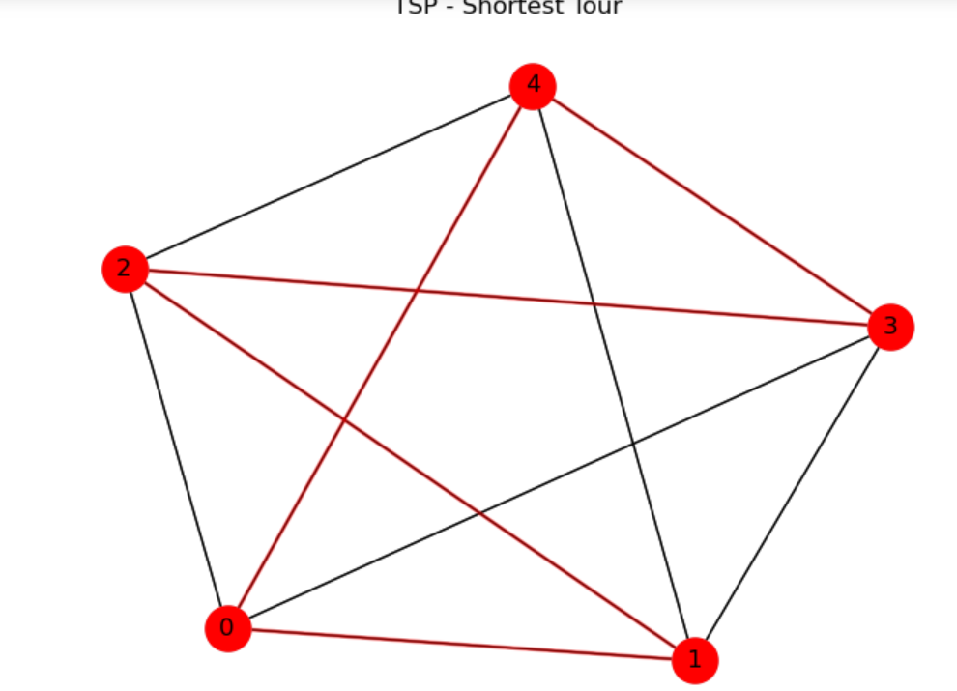

**References**

Applegate, D., Bixby, R., Chvátal, V., & Cook, W. (2006). *"The Traveling Salesman Problem: A Computational Study."* Princeton University Press.

Reinelt, G. (1994). *"The Traveling Salesman: Computational Solutions for TSP Applications."* Springer Science & Business Media.